Technical Report
Stage 1 Description:
For the first stage, we established a demand generator using a Poisson distribution to forecast the total unconstrained nightly demand for each center under two distinct scenarios: Moderate (-5°C) and Extreme (-15°C). To do this, we input base hourly arrival rates which are based on historical occupancy data and multiplied them by the 12-hour operational window to get the nightly arrivals. Furthermore, our model reflects real-world operational constraints: the Cecil and Jimmie Simpson centers remain closed during Moderate conditions but are activated during Extreme conditions where overall systemic demand surges by 10% illustrated by the data we have collected. By running this simulation for over 1,000 iterations using python, we captured the stochastic nature of nightly arrivals to help us decide the average expected demand for each center. These results will serve as foundational inputs for our mixed integer linear programming (MILP) optimization model in Stage 2.
Please see Jupyter notebook: 01_demand_simulation for more details.
Stage 1 Results:
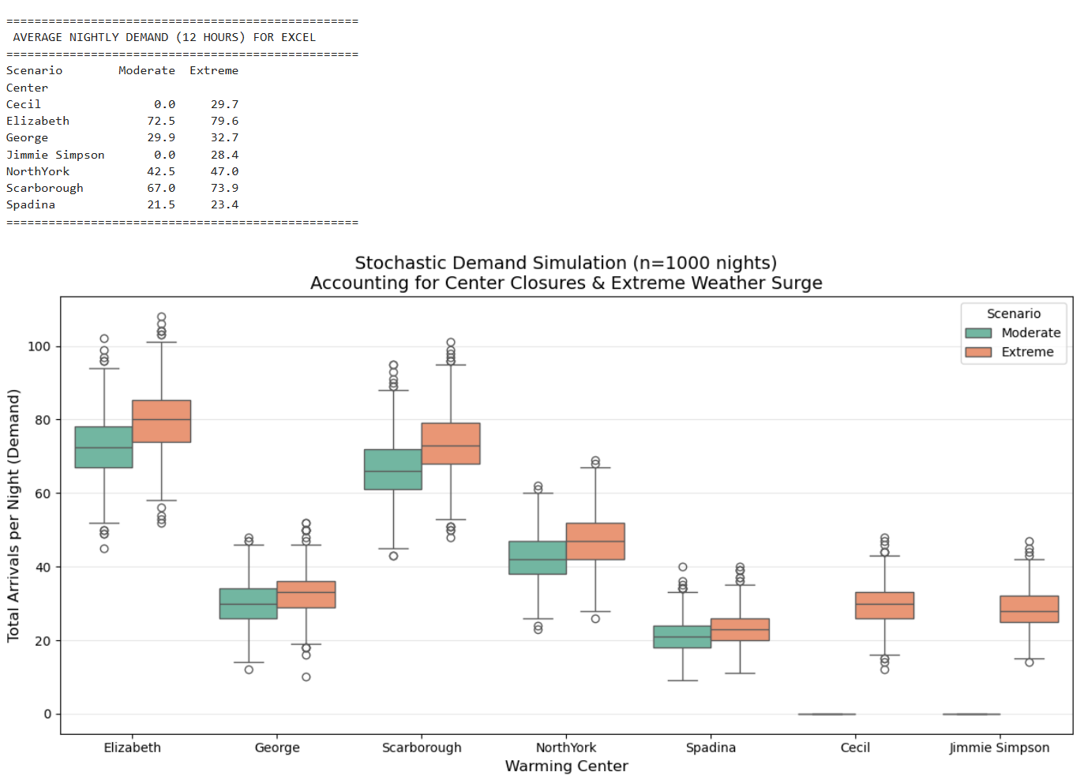
Stage 2 Description:
In Stage 2, the demand estimates generated from the previous stage are used as inputs for our Integer Linear Programming model. The primary objective of this model is to maximize the expected net social welfare across all seven warming centers while offering the best staffing level that can be accommodated to any weather conditions.
To achieve this objective, we established three key parameters: utility per admission, disutility per transfer, and a penalty for turn-aways (rejections). The admission utility is decided by considering the emergency medical costs that can be avoided. The transfer disutility reflects the physical discomfort caused by relocating an individual between centers. Lastly, we set the rejection penalty to 4× the admission utility, calibrated against the average emergency-room cost of treating cold-related conditions such as frostbite (≈ $1,866/day per CIHI). This asymmetric weighting signals to the solver that turning someone away in winter is a far worse outcome than absorbing the operational cost of admission or transfer to encourage the solver minimize transfers and turn-aways as much as possible.
Furthermore, based on historical weather data from January and February over the past three years, we determined the probability of Moderate weather to be 88% and Extreme weather to be 12%. The social welfare for each scenario is calculated using the following formula: (Utility × Admissions) - (Disutility × Transfers) - (Penalty × Rejections).
Ultimately, the model calculates the probability-weighted sum of both scenarios to determine the overall expected welfare as an objective. By maximizing this value, the integer programming model determines one optimal staffing allocation across the centers. This ensures that the chosen staffing level can effectively handle both weather scenarios while strictly following budget, fixed capacity, in-out flow, and staff-to-guest ratio constraints.
Please see excel sheet: 02_milp_optimizatio_model for more details.
Verbal Model:
Decision Variables:
Staff: F(i):
Number of employees for each center i
Transit:
T(i,j,s): Under the weather condition of s, the number of people transfer from center i to center j

Turnaway:
TA(i,s): Under the weather condition of s, the number of people have been turned away at center i
Admit:
A(i,s): Under the weather condition of s, the number of people stay at center i

Parameters:
I: Sets for 7 warming centers: i,j ∈ {Elizabeth, George, Scarborough, North York,
Spadina, Cecil, Jimmie Simpson}
S: Sets for weather condition: s ∈ {Moderate, Extreme} -> Moderate stands for weather at –5 degrees threshold, extreme stands for –15 degrees.
Budget:
B: Total available government budget available for these 7 centers.
Capacity:
Cap (i): The physical bed capacity that is available for each center i, j
Ratio:
R: The max number of clients each staff can manage
Cost:
C(staff): Cost per staff member per shift
C(transit): Cost of transferring one individual from i to j per transit
C(operational): Cost per person admitted (e.g. food, blanket)
Probability:
Prob(s): Probability of s weather conditions
Demand:
Demand (i,s): Under weather condition s, the number of individuals will head to center i
Welfare:
Admission(utility): The positive social impact generated per admission.
Transfer(disutility): The negative social impact generated per transfer.
Rejections(penalty): The negative social impact generated per turn-away.

Constraints:
Limitation of physical bed in each facility:
A(i,s) <= Cap(i)
Staff Capacity Limitations:
A(i,s) <= Staff(i) * Ratio
Integer and Non-Negativity Constraints:
Staff(i), Transit(i,j,s), Turnaway(i,s), Admit(i,s) >= 0 and they are integers
Network Flow Conservation:
Ensure every person in the data is included in the model
For each center: Demand + Transfer Out – Admit - Turn Away-Transfer In =0
Global Budget:
The sum of staffing costs and the expected costs (transit and consumables) must not exceed the total budget.
Operational cost + Staff cost - Budget <= 0
Objective:
Maximize the total expected social welfare for two scenarios based on their probability:
[(Utility × Admissions) - (Disutility × Transfers) - (Penalty × Rejections)] * Prob (Moderate)+ [(Utility × Admissions) - (Disutility × Transfers) - (Penalty × Rejections)] * Prob (Extreme)

Screenshots of Excel:
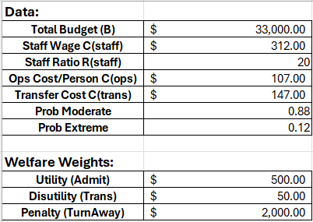

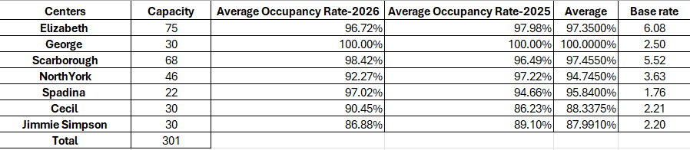
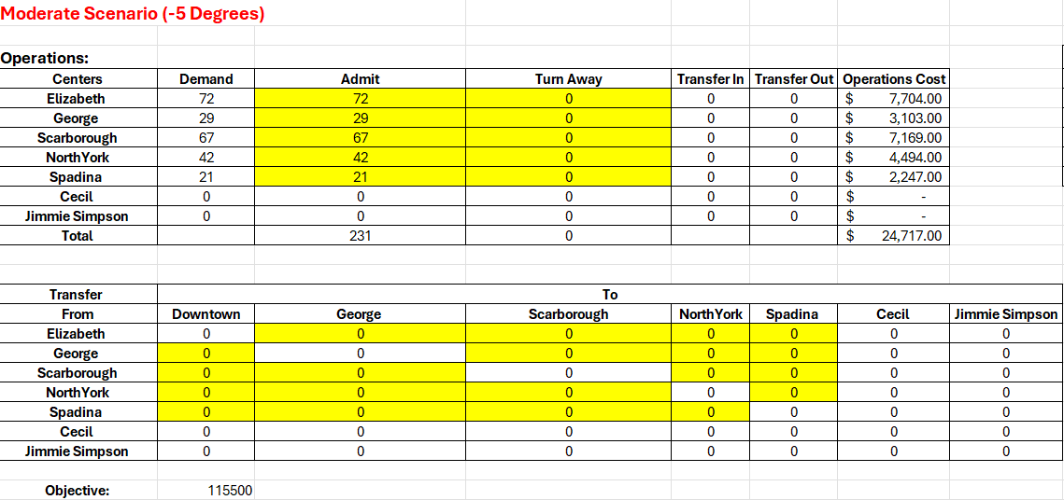

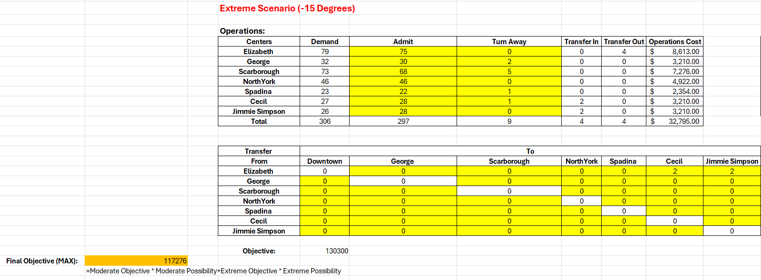
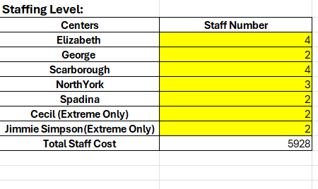

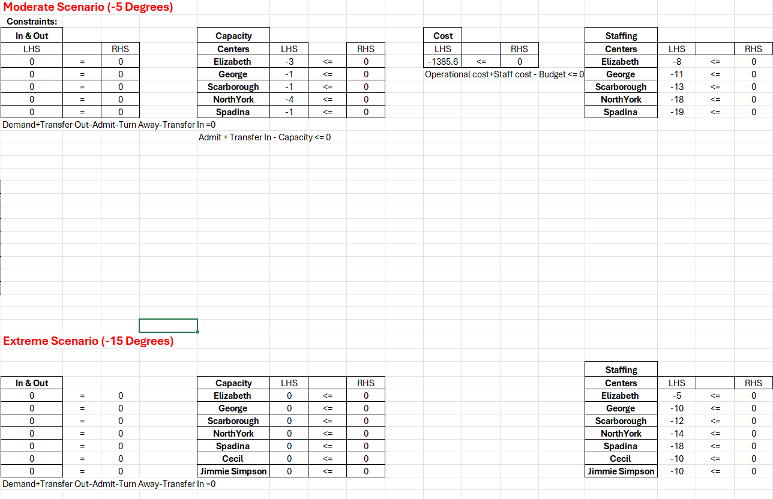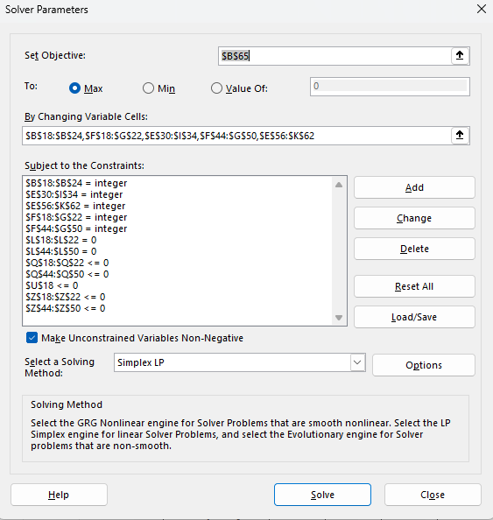
Stage 3 Description
Even though the LP/IP formulation gives us the optimal staffing solution under the assumption that demand equals its mean value, this solution might not necessarily optimal when demand is uncertain, especially under real world cases.
Therefore, to evaluate the robustness of our integer linear programming solution, we need to validate its effectiveness by comparing its performance to other staffing policies under uncertain demands. To do this, we have set two other benchmarks as control groups, the first one is safety buffer, which assumes each center will receive historical peak demand nightly and hire additional workers into each center to handle unexpected demand increase, while the second one Proportional Allocation approach is based on historical average demand of each center. We then built a 5,000-iteration Monte Carlo simulation within a strictly controlled environment to stress-test these three approaches. We modeled nightly arrivals using a Poisson distribution based on weather probabilities, while maintaining the exact same constraints as Stage 2.
Please see Jupyter notebook: 03_robustness_test for more details and visual results below:
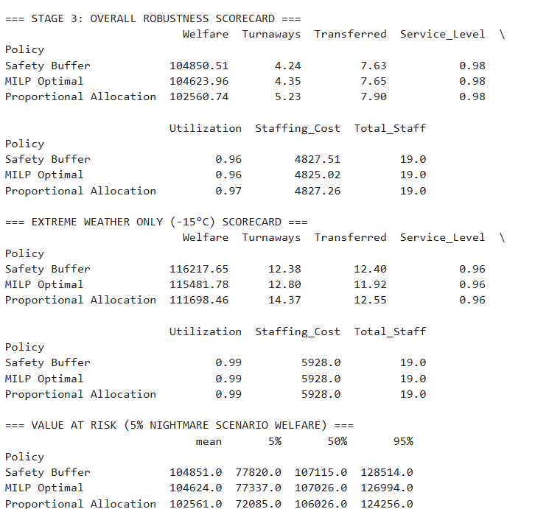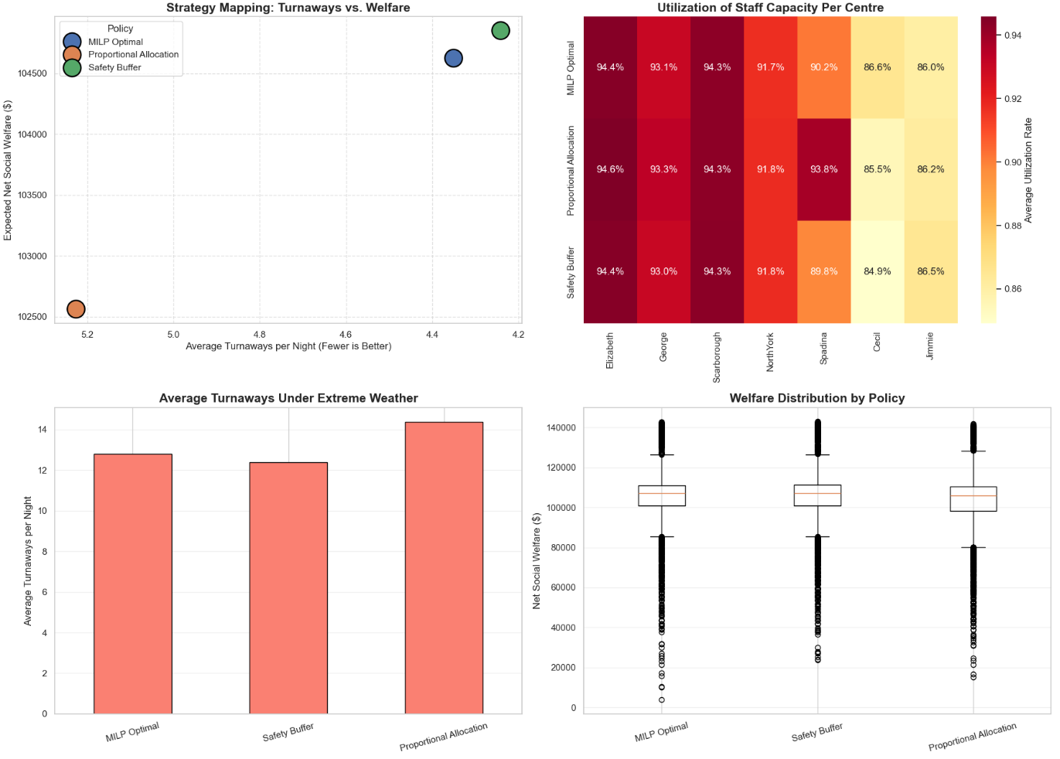
Final Stage:
As shown in the scatter plot above, the Safety Buffer approach slightly outperformed our base MILP model. However, the number of individuals that the staff can manage, based on the staffing level from stage 2, has already exceeded the fixed bed capacity of each center. Therefore, as shown in the results above, for the safety buffer approach, it will also result in the exact same 19-staff distribution as the IP/LP solution. Even though safety buffers receive better results during this stress-test, integer linear programming solution is associated with the budget and constraint of the overall system, which makes IP/LP solution a more appropriate operational base plan. Furthermore, this led us to a crucial insight: hiring more staff alone hits a hard ceiling — the number of physical beds available. Therefore, even if we wanted to hire more staff for each center, it would be pointless as the physical beds are already maxed out.
This mathematically proves that the bottleneck of the system is not operationally efficient, but insufficient for physical beds. So, for the next step, we will utilize the residual budget to add 10 new beds to the system and compare the results.
To achieve that, we ran a new 5,000-iteration simulation to test three different capital distribution methods, applying them to our MILP staffing plan:
Equal Expansion: Distributing the 10 beds equally across all 7 centers.
Proportional Expansion: Distributing them proportionally based on historical average demand.
Targeted Hubs: Adding exactly 5 beds to our two busiest bottlenecks: Elizabeth and Scarborough.
Lastly, we put this 'Targeted MILP Expansion' head-to-head against the original Safety Buffer approach to reach our conclusion: applying our IP/LP solution as the staffing level, while adding 5 beds to each of the Elizabeth and Scarborough centers.
As shown in the final results below, because the safety buffer cannot adapt to the changing budget—since its staffing level is determined based on each individual center without considering the overall constraints across all 7 centers like the integer model does—we will still apply our integer model's optimal staffing level as the final recommendation, while adding 5 beds each to the Elizabeth and Scarborough centers.
Please see Jupyter notebook: 04_ capacity_expansion for more details and visual results below:

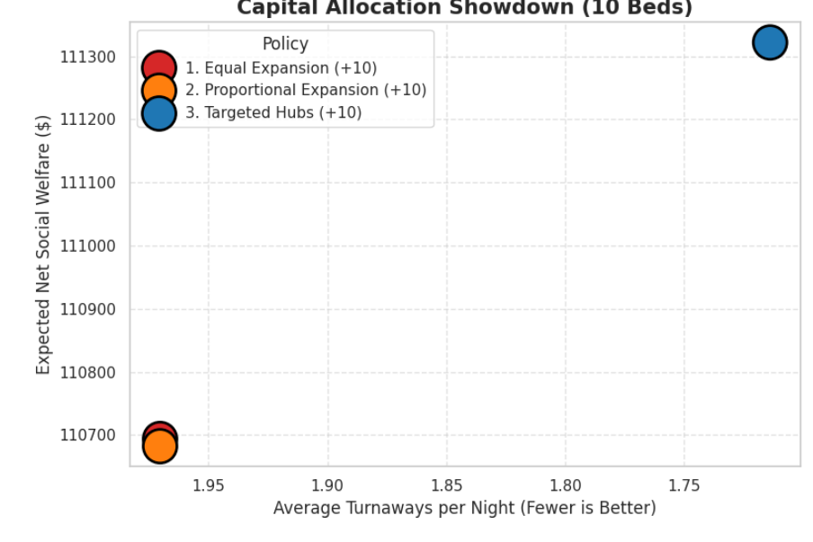
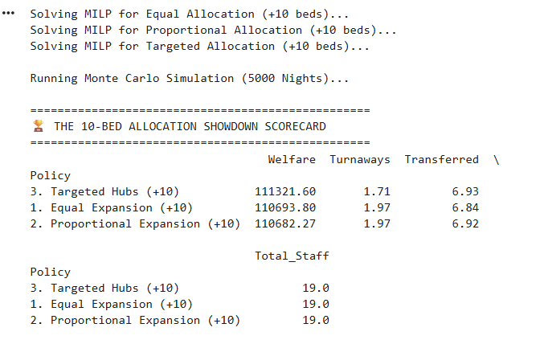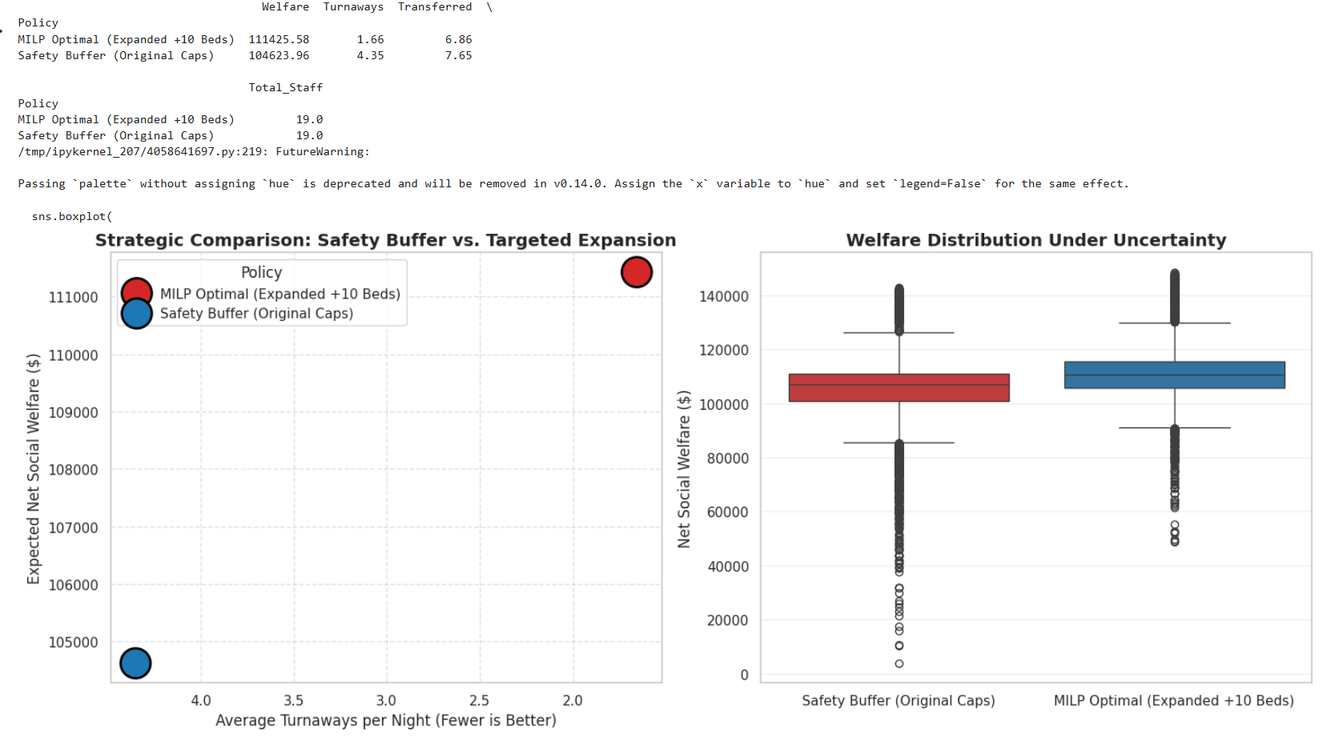

Data Collection:

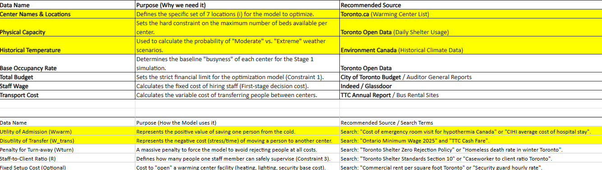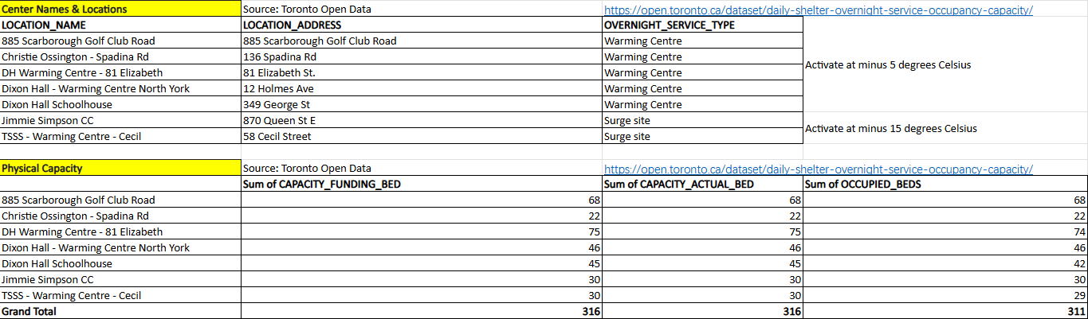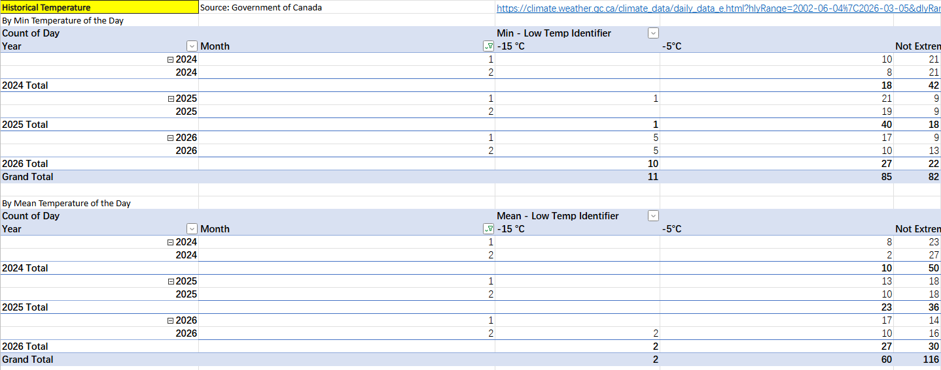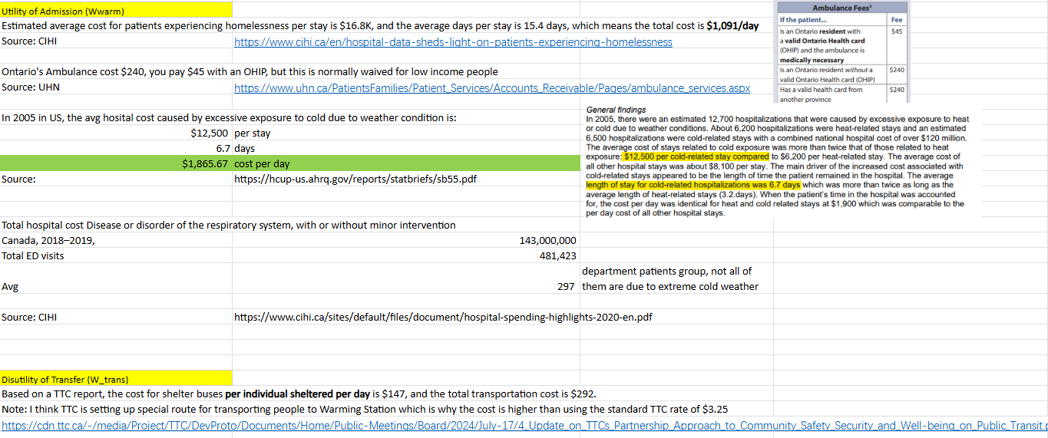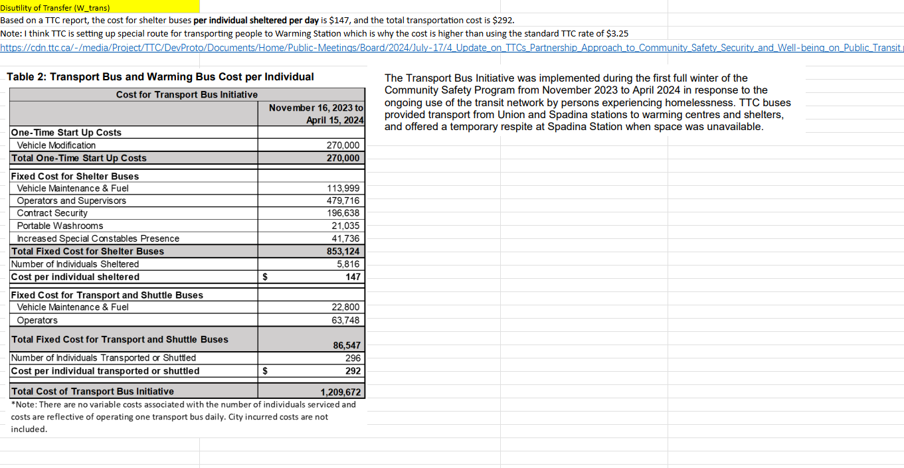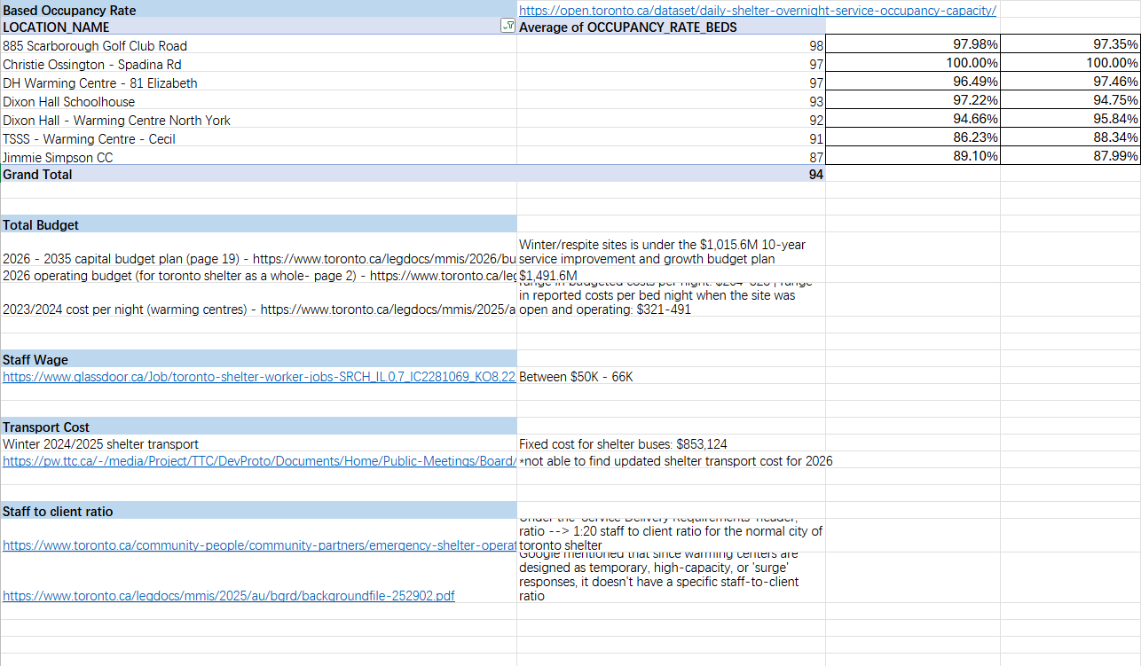

1. Real Center Names & Capacities
Goal: We need the actual names of 5-7 warming centers to use in our code labels.
How to Search:
Search: "City of Toronto warming center locations list 2025" or "Winter Services Plan Map".
What to Extract:
List 5-7 specific names (e.g., Metro Hall, Scarborough Civic Centre, Mitchell Field CC).
Note their region (Downtown, North York, Scarborough, etc.).
Warming Centre Name | Address | Region | Approximate Capacity | OVERNIGHTSERVICE TYPE
81 Elizabeth Street | 81 Elizabeth St | Downtown Toronto | 75 | Warming Centre
12 Holmes Avenue | 12 Holmes Ave | North York | 46 | Warming Centre
The John Innes Community Centre | 150 Sherbourne St | Downtown Toronto | 50 | Surge site
885 Scarborough Golf Club Road | 885 Scarborough Golf Club Rd | Scarborough | 68 | Warming Centre
Cecil Community Centre | 58 Cecil St | Downtown Toronto | 58 | Surge site
CONC Christie Ossington Neighbourhood Centre | 136 Spadina Rd | Downtown Toronto | 22 | Warming Centre
Dixon Hall - The Schoolhouse | 349 George St | Downtown Toronto | 30 | Warming Centre
Region summary：
Downtown Toronto: 81 Elizabeth St, Cecil Community Centre, The John Innes Community Centre, Dixon Hall - The Schoolhouse, Ossington Neighbourhood Centre
North York: 12 Holmes Avenue
Scarborough: 885 Scarborough Golf Club Rd
Resources:
https://www.toronto.ca/community-people/housing-shelter/homeless-help/toronto-warming-centres/
https://www.toronto.ca/community-people/housing-shelter/homeless-help/24-hour-respite-sites/#location=&lat=43.638063&lng=-79.210739&zoom=10

2. Base Arrival Rates (How busy are centers normally?)
Goal: We need the "People per Hour" arrival rate (lambda) for 7 warming centers on a standard winter night.
How to Search:
Go to: Toronto Open Data Portal
Search: "Daily Shelter Overnight Service Usage" or "Warming Center Occupancy Statistics 2024"
What to Extract:
Download the CSV file. Filter for December, January, and February.
Find the Average Nightly Occupancy for 7 centers (e.g., Metro Hall, Scarborough Civic Centre).
The Calculation (Important):
The data usually shows "Total Occupancy" (e.g., 90 people/night).
Divide this by 12 (assuming a 7 PM - 7 AM shift) to get the Hourly Arrival Rate.
Example: 90 people / 12 hours = 7.5 people/hour.
Using the 2025 information provided on the website and the Daily Shelter Overnight Occupancy dataset, https://open.toronto.ca/dataset/daily-shelter-overnight-service-occupancy-capacity/ the data for these 7 warming centres from December to March 8th was organized and unnecessary variables were removed. The table shows the final cleaned dataset (on shared folder).

Centre | Avg Occupancy | λ(average occupied beds /12 hour)
136 Spadina Rd | 95.48% | 1.76
885 Scarborough Golf Club Rd | 97.45% | 5.52
81 Elizabeth St | 97.35% | 6.08
349 George St | 100% | 2.5
North York | 94.75% | 3.63
58 Cecil St | 88.3% | 2.2
Jimmie Simpson | 87.99% | 2.2

Overall, the data shows that most warming centres operate at very high occupancy during the winter months. Many locations are close to full capacity on most nights, which suggests that the demand for warming services is consistently high. However, there are some fluctuations at certain centres and dates, likely because some locations operate as surge sites and are not open every night. The estimated arrival rates also differ across locations, with downtown centres generally receiving more people per hour than others.
Warming centres typically operate overnight during cold alerts. Although the exact hours may vary depending on weather conditions, this analysis assumes a 12-hour service window from 7 PM to 7 AM to estimate the hourly arrival rate.

3. Weather Multiplier (How does cold affect demand?)
Goal: We need a specific multiplier for our "Extreme Cold" scenario. (e.g., Does demand increase by 1.5x or 2.0x when an Extreme Cold Alert is issued?)
How to Search:
Search Google for: "Toronto warming center demand surge extreme cold alert" or "Homelessness capacity crisis winter storm Toronto".
Look for news articles (CBC, CityNews, Toronto Star) or City Staff Reports.
What to Look For:
Quotes like: "Demand surged by 40% during the cold snap" or "Capacity doubled."
If you find "40% increase," our Multiplier is 1.4.
If you can't find an exact number, look for qualitative reports describing "overflowing centers" so we can justify using a high multiplier (e.g., 2.0) as a reasonable assumption.

4. Variable Costs (Food & Transport)
Goal: We need to split the cost into 'Fixed' (Staff) and 'Variable' (Food/Supplies).
Search: "Toronto warming center bed cost breakdown" or "Shelter meal per diem rate".
What to find:
Find the total cost of a meal/snack/blanket per person for every stay (like around $15-$20).
Find the Total Operating Cost per night for a warming center (likely **$10,000 - $30,000**). We need this "Total" number to set our Global Budget Limit (B) in the model.

Output Needed:
Could you put these findings into a simple Excel sheet or list?
Column 1: Center Name
Column 2: Base Hourly Arrival Rate (calculated from Open Data)
Column 3: Weather Multiplier (with the news link/source)

Staff Ratio R(staff)
1:20
https://www.toronto.ca/community-people/community-partners/emergency-shelter-operators/expressions-of-interest/homelessness-shelter-operator-expression-of-interest/#:~:text=Staffing%20Requirements%20*%20Maintain%20required%20staffing%20levels%2C,First%2C%20and%20relevant%20health%20and%20safety%20regulations
Staffing cost
$26 per hour
https://ca.indeed.com/career/shelter-worker/salaries/Toronto--ON
https://www.glassdoor.ca/Job/toronto-shelter-worker-jobs-SRCH_IL.0,7_IC2281069_KO8,22.htm
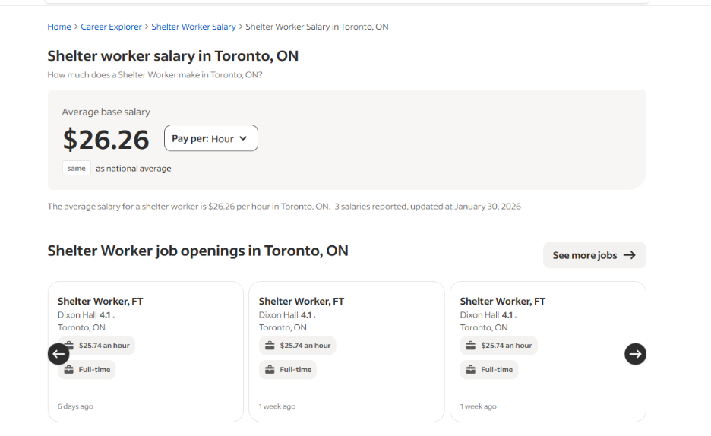

Average Cost per Bed
$359 (within staffing) X 30% = 107
chrome-extension://efaidnbmnnnibpcajpcglclefindmkaj/https://www.toronto.ca/legdocs/mmis/2025/au/bgrd/backgroundfile-252939.pdf
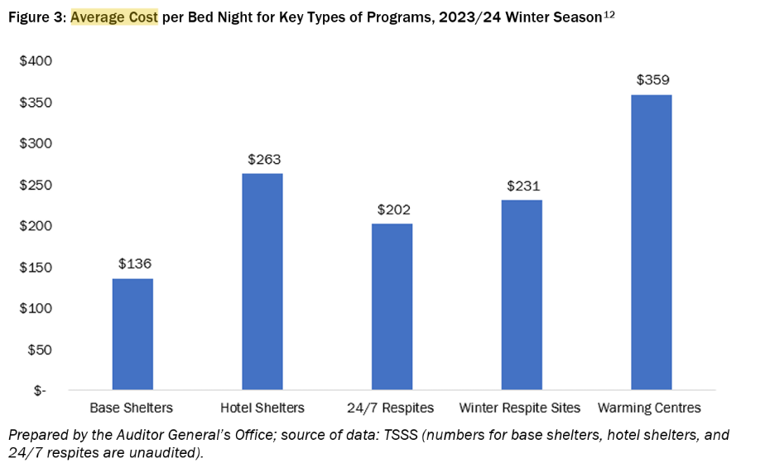Transfer cost
$147
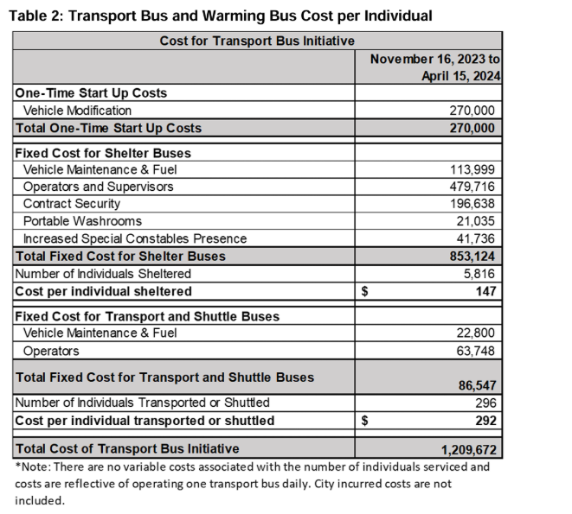
Demand increases under extreme weather
10%
https://www.ices.on.ca/publications/journal-articles/trends-in-emergency-department-visits-during-cold-weather-seasons/

Government budget:
Based on the City's reported seasonal spending of $22.2M over an approx. 150-day winter season, the gross daily burn rate is ~$148,000.
Since our MILP model focuses strictly on direct variable costs (staffing, consumables, transport) and excludes fixed overheads (rent, admin, third-party surpluses), we conservatively estimate the available daily operating budget to be 50% of the gross rate, resulting in a constraint of $75,000 per night.
As respite program sharing the same budget with warming centers, so Warming centers share is 301/700 * 75000 = $33000
https://www.torontoauditor.ca/report/audit-of-toronto-shelter-and-support-services-warming-centres-and-winter-respite-sites-understanding-and-addressing-demand-while-improving-financial-accountability-to-stretch-dollars-furthe/#:~:text=By%20The%20Numbers,rates%20for%20salaries%20and%20meals)
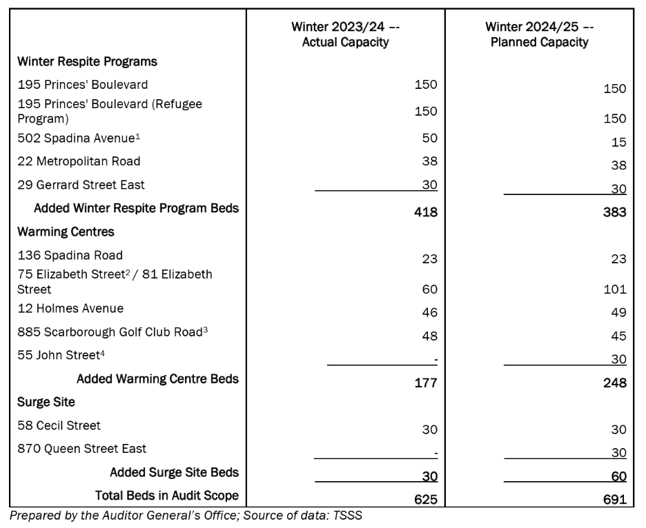

Turned away
220*301/12200 = 6
Average 6 people have been turned away
12,200 people are currently being supported in the shelter system and outside the shelter system in bridging hotels, and an average of 223 people are turned away
https://www.torontotoday.ca/local/crime-emergency-services/several-toronto-warming-centres-full-capacity-as-advocates-allege-people-being-turned-away-11786211#:~:text=I%20have%20had%202%20reports,(@cathyacrowe)%20January%2024%2C%202026
AI Disclosure: ​
Google Gemini and OpenAI ChatGPT were used for brainstorming, language editing, paraphrasing, and limited coding support during the preparation of this report. All substantive analysis, optimization logic, interpretation of results, and final recommendations were developed and approved by the team. Specific AI-assisted content included in this report has been disclosed and cited in the References section in accordance with course requirements.
Reference
Google. (2026). Gemini. Accessed March 18, 2026, https://gemini.google.com/app.
OpenAI. (2026). ChatGPT. Accessed March 18, 2026, https://chatgpt.com.
City of Toronto. (n.d.). Warming centres. https://www.toronto.ca/community-people/housing-shelter/homeless-help/toronto-warming-centres/
City of Toronto. (2025). Daily shelter & overnight service occupancy & capacity [Data set]. https://open.toronto.ca/dataset/daily-shelter-overnight-service-occupancy-capacity/
City of Toronto. (2024). Homelessness & shelter operator expression of interest. https://www.toronto.ca/community-people/community-partners/emergency-shelter-operators/expressions-of-interest/homelessness-shelter-operator-expression-of-interest/
Toronto Today. (2026, January 24). Several Toronto warming centres full capacity as advocates allege people being turned away. https://www.torontotoday.ca/local/crime-emergency-services/several-toronto-warming-centres-full-capacity-as-advocates-allege-people-being-turned-away-11786211
Toronto Auditor General. (2025). Audit of Toronto Shelter and Support Services warming centres and winter respite sites: Understanding and addressing demand while improving financial accountability to stretch dollars further. https://www.torontoauditor.ca/report/audit-of-toronto-shelter-and-support-services-warming-centres-and-winter-respite-sites-understanding-and-addressing-demand-while-improving-financial-accountability-to-stretch-dollars-furthe/
Richard, L., Richard, K., Guttmann, A., & Stukel, T. A. (2023). Trends in emergency department visits during cold weather seasons. Journal of Clinical Epidemiology [or relevant journal name]. https://www.ices.on.ca/publications/journal-articles/trends-in-emergency-department-visits-during-cold-weather-seasons/
City of Toronto. (2025). Audit of Toronto Shelter and Support Services warming centres and winter respite sites: Understanding and addressing demand while improving financial accountability to stretch dollars further (Background File No. 252939). https://www.toronto.ca/legdocs/mmis/2025/au/bgrd/backgroundfile-252939.pdf
Glassdoor. (n.d.). Shelter worker jobs in Toronto, ON. Retrieved March 20, 2026, from https://www.glassdoor.ca/Job/toronto-shelter-worker-jobs-SRCH_IL.0,7_IC2281069_KO8,22.htm
Toronto Transit Commission. (2024, July 17). Update on TTC’s partnership approach to community safety, security and well-being on public transit (Report No. 4). https://cdn.ttc.ca/-/media/Project/TTC/DevProto/Documents/Home/Public-Meetings/Board/2024/July-17/4_Update_on_TTCs_Partnership_Approach_to_Community_Safety_Security_and_Well-being_on_Public_Transit.pdf
University Health Network. (n.d.). Ambulance services. Retrieved March 20, 2026, from https://www.uhn.ca/PatientsFamilies/Patient_Services/Accounts_Receivable/Pages/ambulance_services.aspx
Environment and Climate Change Canada. (2026). Daily data report for January 2026: Toronto City, Ontario [Data set]. https://climate.weather.gc.ca/climate_data/daily_data_e.html?hlyRange=2002-06-04%7C2026-03-05&dlyRange=2002-06-04%7C2026-03-05&mlyRange=2003-07-01%7C2006-12-01&climate_id=6158355&Prov=ON&urlExtension=_e.html&searchType=stnProx&optLimit=yearRange&StartYear=2024&EndYear=2026&selRowPerPage=25&Line=0&txtRadius=25&optProxType=city&selCity=43%7C39%7C79%7C23%7CToronto&selPark=&txtCentralLatDeg=&txtCentralLatMin=0&txtCentralLatSec=0&txtCentralLongDeg=&txtCentralLongMin=0&txtCentralLongSec=0&txtLatDecDeg=&txtLongDecDeg=&timeframe=2&Day=1&Year=2026&Month=1#

